Avon Grove Library
March 2024 Programs
Facebook.com/AGLibrary @avongrovelibrary  LOCAL HISTORY SPEAKER SERIES  Author Mark DeWitt Lanyon  “Lost Chester County Pennsylvania”  Thursday, March 14, 6:30 PM | 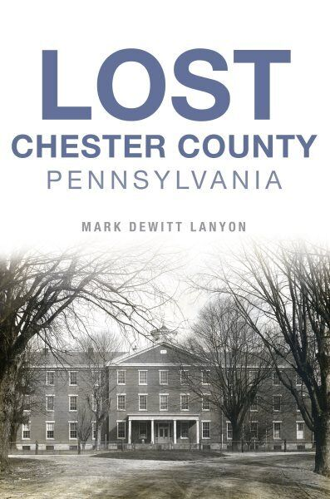
Monday | Tuesday | Wednesday | Thursday | Friday | Saturday
 |  |  |  | 1  10 AM Kids Craft Kits**  10AM Sensory Storytime | 2  11 AM PAWS for Reading*
4 | 5  9:30 & 11 AM  Toddler Tuesday | 6  3 PM Teen Gaming Club | 7  10 AM Preschool Storytime | 8  10 AM Teen Craft Kits**  10 AM Crafty Kids Corner* | 9  10 & 11 AM STEM Saturday*
11 | 12  9:30 & 11 AM  Toddler Tuesday | 13  10AM Stories & Stretching | 14  10 AM Preschool Storytime  6:30 PM Local Speaker Series: Mark DeWitt Lanyon | 15  10 AM Adult Craft Kits**  10 AM Sensory Storytime | 16  Preparing for the April 8 Solar Eclipse (School Age/Teens)  10:30 AM  (grades 3-5)  12 PM  (grade 6 and up)
18 | 19  9:30 & 11 AM  Toddler Tuesday  5pm Middle School Book Club  6:30pm High School Book Club | 20  3 PM Teen Gaming Club  6:30 PM Preparing for the April 8 Solar Eclipse (Adults) | 21  10 AM Preschool Storytime  6:30PM Chess Club*  6:30 PM Book Club for Adults | 22  10 AM Crafty Kids Corner* | 23  10AM Friends of the Library Used Book Sale
25  ___________________  31 | 26  9:30 & 11 AM  Toddler Tuesday | 27  10AM Stories & Stretching  3 PM Teen Dungeons and Dragons* | 28  10 AM Preschool Storytime | 29 | 30  10:30 AM STEM Saturday Teens*
Program Highlights
* = Must register online at https://ccls.libcal.com/calendar/AvonGrove/ (QR code below)
All programs are free unless otherwise noted. Full program schedule available at www.avongrovelibrary.org.
Family/Children’s Programs
Toddler Tuesday Storytimes: Tuesdays at 9:30 and 11AM, Library Activity Room
Preschool Storytime: Thursdays at 10AM, Library Activity Room

Sensory Storytimes (Ages 3+ and their caregivers)
March 1 and 15, 10-10:45 AM
Our Sensory Storytime aims to create a shared experience through engaging stories, songs, fingerplays, & interactive sensory play. This unique program is designed with sensory needs in mind, but we welcome everyone to participate.

Crafty Kids Corner* (Ages 3+)
March 8 and 22, 10-11 AM
Join us for festive Winter Crafts! Explore colors & themes while creating age-appropriate crafts. Registration required.

School Age & Teen Programs
For more info about these programs, scan the QR code below & click on the event for details & to register, if required.

STEM Saturday* (Grades K-2) Saturday, March 9, 10 AM
STEM Saturday* (Grades 3-5) Saturday, March 9, 11 AM
Explore, imagine, create, and PLAY with us in this hands-on makerspace program. Registration required.

Preparing for the April 8 Solar Eclipse* Saturday, March 16
10:30 AM (Grades 3-5) Noon (Grade 6 and up)
An event you won’t want to miss! Attendees can pick up approved solar eclipse glasses you can keep for viewing the April 8 event. Registration required.

STEM Saturday for Teens* (Grades 6-12)
Saturday March 30, 10:30 AM -1 PM (and select Saturdays throughout 2024)
Brought in Part by a PASmart grant through VGCUSA (Video Game Clubs of America. Topic is: Content Creation with iPad for Views, Youtube Channel Creation. Registration required.

Adult Programs
Local History Speaker Series: Mark DeWitt Lanyon Thursday March 14, 6:30PM
Avon Grove Library partners with the West Grove Museum. Author Mark DeWitt Lanyon will discuss his latest book "Lost: Chester County Pennsylvania." He charts the county's lost history and shares his knowledge of its may historic landmarks.

Lincoln University – Past, Present and Future Tuesday March 19, 6:30PM
Join us for a community conversation with a panel of Lincoln University students, past and present, to learn about their experiences and perspectives on student life and community. This event is a partnership between Lincoln University and the Avon Grove and Oxford Libraries. It will take place in the Katherine B. Alexander Room at the Oxford Library.

Preparing for the April 8 Solar Eclipse (Adults)* Wednesday, March 20, 6:30PM
10:30 AM (Grades 3-5) Noon (Grade 6 and up)An event you won’t want to miss! Attendees can pick up approved solar eclipse glasses you can keep for viewing the April 8 event. Registration required
.